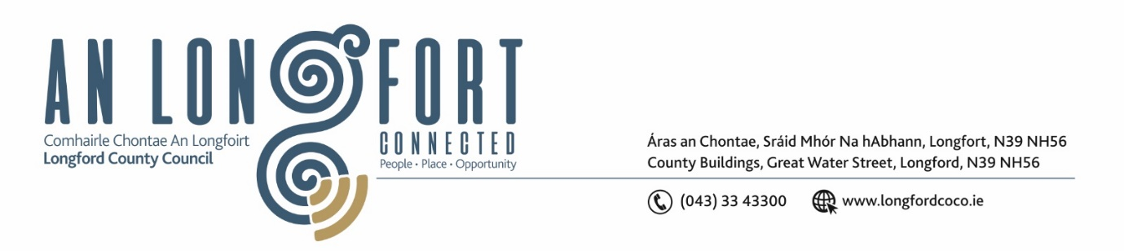

***Please note meeting will be held via Microsoft Teams.***

**15ú Meitheamh 2021.**

**Chuig: Gach Ball don Chomhairle.**

A Chomhairleoir,

Iarrtar ort bheith i láthair ag Cruinniú Speisialta Chontae Longfoirt a tionólfar via MS Teams are an **Dé Luain, 21ú Meitheamh 2021 ag 3pm** chun gnó a dhéanamh d’réir an Chláir thíos.

You are requested to attend **a Special Meeting** of Longford County Council to be held **via Microsoft Teams** on **Monday, 21st June 2021 at 3pm** to transact business, as set out on the Agenda hereunder.

Mise le meas,

*Ann Marie Mc Keon*

**__________________**

**Ann Marie Mc Keon,**

**Meetings Administrator.**

**C L A R**

Prayer before meeting.

**Strategic Infrastructure and Climate Change**

1. Draft Longford County Development Plan 2021 – 2027 and associated Chief Executive Report.

* Errata (A) - CE report recommends the removal of RPS No. 269, however, on review the correct RPS no. is 360.
* Errata (B) – CE recommends the response to Submission 89 be included in the Chief Executive Report

Notices of Motions, submitted by Councillors, as listed hereunder –

**Councillor Seamus Butler**

‘That Longford County Council does not accept the Chief Executive recommendation following on from the OPR submission in regard to Strategic Residential Reserve and that it reverts to the previous wording in the draft County Development Plan which includes the addition of an exceptional circumstance rider. This is in the interests of the proper planning and sustainable development of the area as exceptional circumstances in the future may require some of these lands to be developed to deliver housing in Longford’

**Councillor Paraic Brady**

(i) That the old Presbyterian burial ground in Drumlish not be zoned for Residential purposes but zoned for public utility and that the residential zoning for the old burial ground be relocated to the east on the same road.

(ii) That the land zoned residential reserve on the Old Hill Road leading to the Old School Road be rezoned amenity to better facilitate the amenity path through the village and to better align with the amenity path along the Mill Race.

(iii) That a bridal path be included in the Zoning map for Drumlish similar to the amenity link path and connecting the potential cross-country link to Corn Hill.

**Councillor Pat O’Toole**

I propose that Longford County Council change the use of the former Convent Building and grounds at Upper Main Street Ballymahon from residential use to social, community and utility use.

**Councillor Colm Murray**

(i) I propose that Danesfort House, reference number 358 on the list of protected

structures be removed from the said list.

(ii) I propose that the Thatch Cottage, Keenagh, reference number 276 on the list of

protected structures be removed from the said list.

**Councillor Garry Murtagh**

1. Lands in Ballinalee to be removed from Zoned Residential Reserve to Zoned

Agricultural/Blank in the interest of the proper planning and sustainable development of the area’.

(ii) That the existing exceptional circumstances for development in residential reserve zoning lands be reinstated in the new proposed Draft County Development Plan 2021- 2027 and not be excluded as advised by the OPR and Chief Executives Report.